**Option-1:**

Go to Gerrit GUI <http://172.27.194.36:9100/#/q/status:merged>

* Click on merged and open commit which you want merge to master

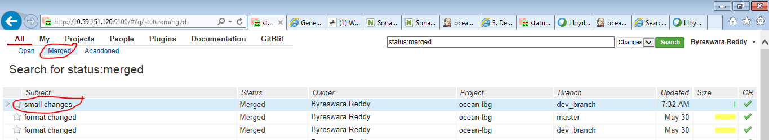

* Click on Cherry Pick and select master on popup window then click on Cherry Pick Change

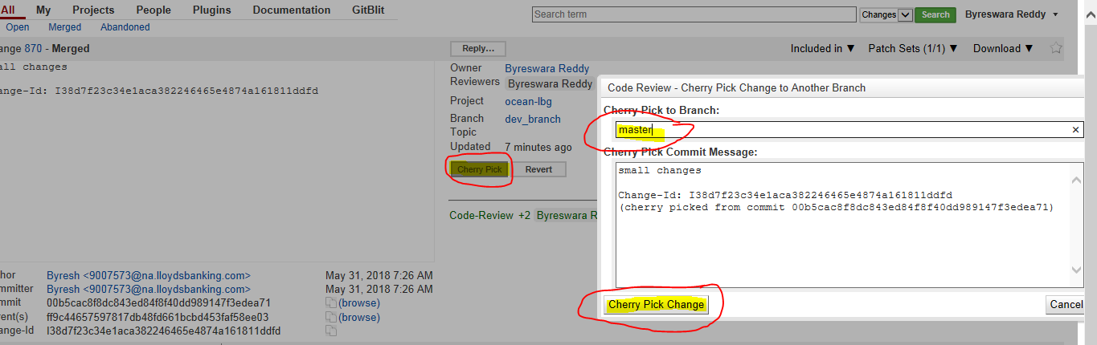

* Then it will come to Open status and ask to get +1 review.

**Option-2:**

If you see cherry pick conflict in Gerrit GUI click continue (see below screen shot) and we need to resolve and push it from Design studio

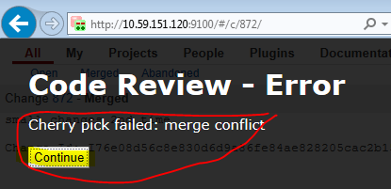

* Checkout to master branch in local (double click on master) see below screen shot
* Click Ok on popup window

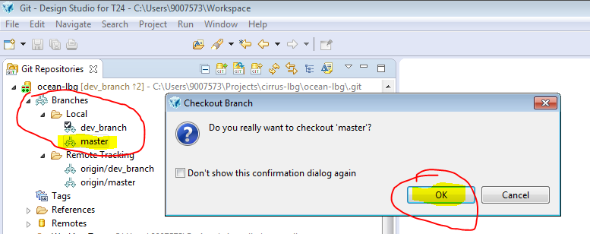

* You can observe TICK mark on master branch (i.e.., you have successfully checked out to master)

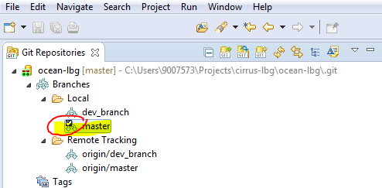

* Right click on ocean-lbg (check below screen shot) and select Fetch From Upstream

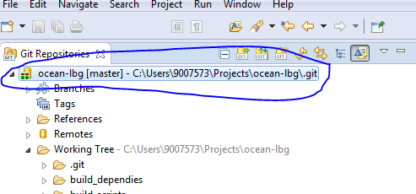

* Right click on ocean-lbg (check below screen shot) and select Rebase...



* Select origin/master and click on Rebase
* Click on Ok on popup window

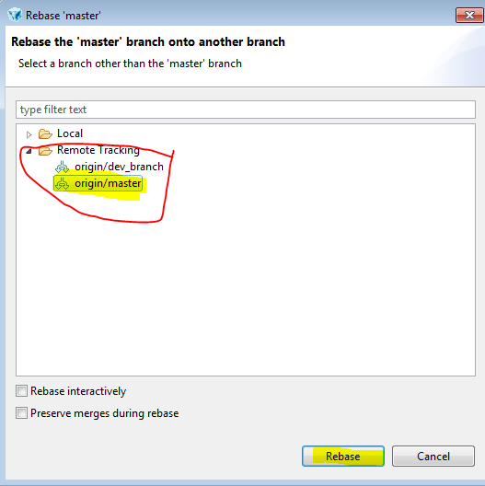

* Right click on ocean-lbg and select Show In -> History
* You can see History and click on show all branches and tags icon (check below screen shot)
* Then you can see dev_branch history also

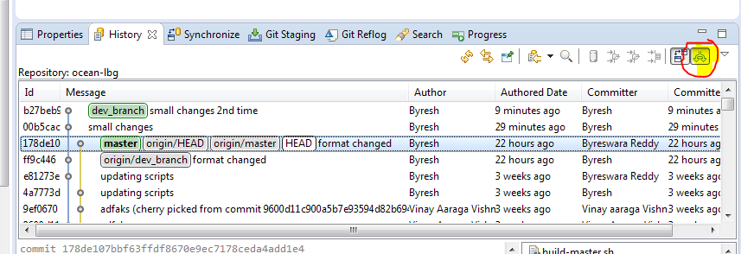

* Right click on commit which you want merge to master and select Cherry Pick…
* Then observe master on popup window then click Ok

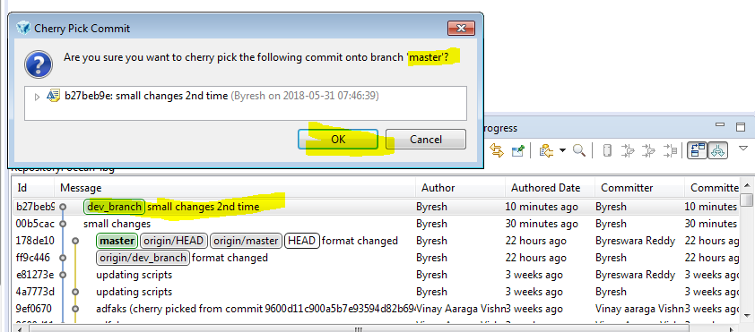

* You can see conflict warning, just click Ok to resolve.

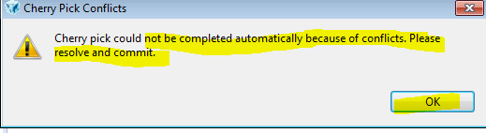

* Right click on routines and select Open Working Tree Version then resolve conflicts and Save it. i.e.., **you can find routines on bottom right corner** (see below screen shot)
* Do it for other routines if any
* You can see conflict indicating symbols

<<< Master

===========

>>>>>>>>>b27be... small changes 2nd time

* above equal line code is latest ( remote changes) and below equal line code is your changes
* keep code which you want push to remote and remove remaining code and also remove conflict indicating symbol lines ( <<< master , =====, >>> >> b27be... )

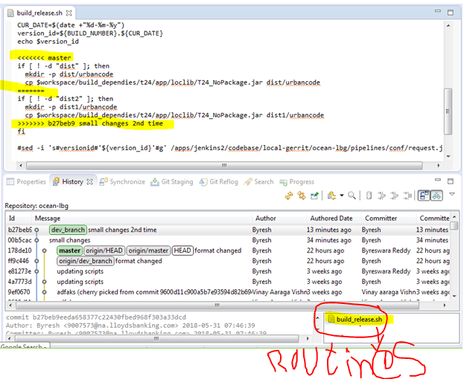

* Click on Git Staging
* Drag routines from Unstaged changes to staged changes
* Write appropriate commit message
* And click on Commit and Push
* Observe master branch on popup window (see below screen shots)

NOTE: Push Only cherry pick commits to master

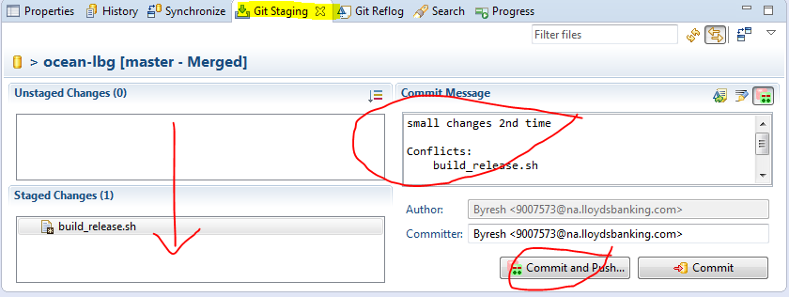

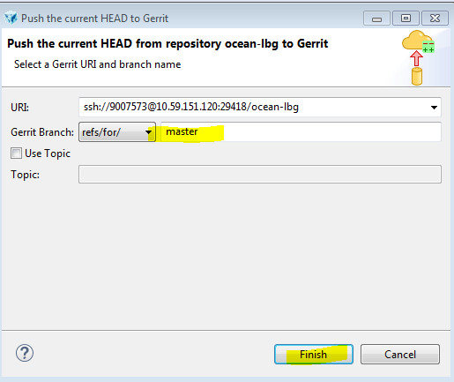

* Checkout to dev_branch in local (double click on dev_branch) see below screen shot
* Click Ok on popup window

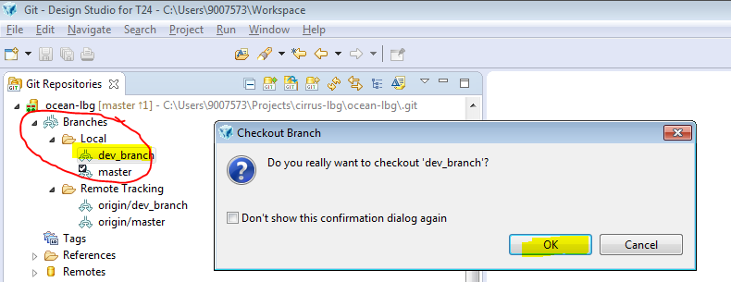

* You can observe TICK mark on dev_branch (i.e.., you have successfully checked out to master)

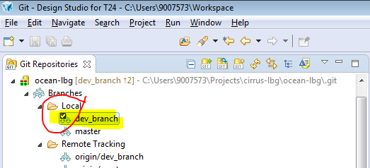

* You can see pushed routines in Gerrit GUI

